Student training records
All students enrolling on the vocational component of Bar training will have a training record maintained by the BSB. The training record contains details of the academic, vocational and pupillage/work-based components of training for the Bar. Successful completion of the three components qualifies a student to begin practising at the Bar in England & Wales. Students can view their training record on the secure MyBar portal.
The information for the academic and vocational components is provided by the Authorised Education and Training Organisation(s) (AETO) at which the student is enrolled.

AETOs
The AETO (you) are responsible for providing the BSB with an accurate record of the students enrolled on the vocational component of Bar training and their module and overall results.
Authorisations Team
The Authorisations Team (we) will receive the data provided by the AETOs and verify that it meets the requirements for the student training records. Once verified we will import the data into our systems. Where a training record already exists for a student, this will be updated with the new data. We will create a new training record for all other students.
We will contact the AETO if the data does meet the requirements and ask for it to be resupplied.
Student
The student (you) will receive a “Welcome to MyBar” email when your training record is first created. This will contain instructions for setting up your personal login for the MyBar portal. Within MyBar you will be able to view your training record and access additional services throughout your career at the Bar.
To view your training record, log in to MyBar and then select “My Bar training record” from the left panel:
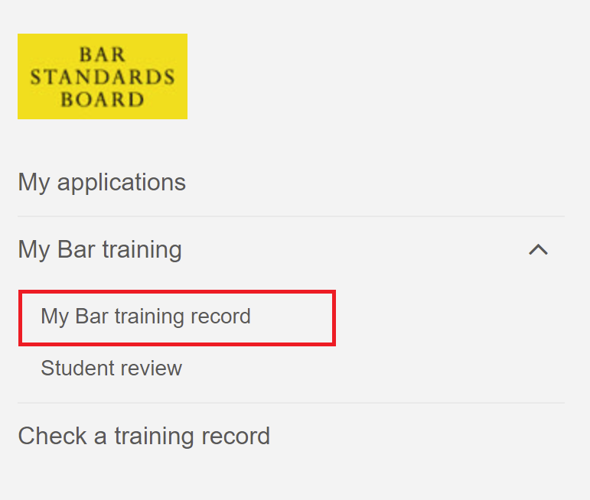
Your training record will display:
- The details of your entry onto Bar training, including your “Unique identification number”;
- Your academic qualifications (or details of any waiver of this requirement);
- Your exam results for the vocational component of Bar training (or details of any waiver of this requirement);
- Details of your pupillage/work-based component (or details of any waiver of this requirement).
The academic and vocational data within your training record comes from your AETO. If you believe any of the data is incorrect, please contact your AETO . Your AETO can supply updated information to us to ensure your training record is accurate.
If you need to share your training record with another organisation, such as a pupillage provider, please provide them with your “Unique identification number” as displayed on your training record. This will allow them to search for your training record through the “Check a training record” function of MyBar. When using this function, your name will be redacted from the training record for security purposes.

FAQs
- [AETO] Can you provide assistance with the process of uploading enrolment and results data? Please refer to the separate guides on suppling enrolment and results data.
- [Student] The other students on my course received a “Welcome to MyBar” email but I did not. What should I do? Check with your AETO which email address they supplied to us with your enrolment data. Your AETO can request an amendment if this is not correct, and we can resend your Welcome email. If your email address was supplied correctly, contact vbtproviders@BarStandardsBoard.org.uk for assistance.
- [Student] The information on my training record is incorrect. What should I do? Contact your AETO so that they can supply updated information to us.
- [Student] When logging into MyBar for the first time I was asked if I wanted to sign up for Bar Standards Board and Bar Council mailing lists. Do I have to do this? No, consenting to receive BSB, Bar Council or Training and Events emails is optional.
- [Student] I have completed the vocational component and now need to register my pupillage. How do I do this? Please refer to the pupillage guidance on our website.

