Results data
The data for all students undertaking exams with an AETO during the vocational component of Bar training must be provided to the BSB. This data forms part of the student’s training record with the BSB. Students can view their training record on the secure MyBar portal.
AETOs
The AETO (you) are responsible for providing the BSB with an accurate record of the exams taken by each student on the vocational component of Bar training. On completion of the vocational component course, you are responsible for providing the BSB with confirmation of the overall result for each student and, where applicable, the date each student successfully completed the course. You will need the latest Excel template for results data and a login for the MyBar portal. If you do not have either the template or access to the MyBar portal, contact vbtproviders@BarStandardsBoard.org.uk for guidance.
You must complete the “Module results” tab of the template with the details of all exam sittings, being careful to fully complete all columns marked in red. Additional guidance is provided on the “Instructions” tab of the template. Ensure that the “Final Result (1-100)” and the “Competent / Not yet competent” fields are completed where applicable. Note that the following modules are not assessed with a score, so you may leave the “Final Result (1-100)” column empty:
- Legal Research
- Professional Ethics
For students who have completed the vocational course, either successfully or unsuccessfully, or withdrawn from the course, you must complete the “Overall results” tab, being careful to fully complete all columns marked in red. Additional guidance is provided on the “Instructions” tab of the template.
You can supply a completed template with both modules results and overall results. You can also supply modules results or overall results on their own, but please ensure that all module results have been supplied if you indicate that a student has successfully completed the course.
All module results supplied to the BSB will be uploaded to the students’ training records, so once a result has been supplied, please do not resend it on any subsequent uploads. Please ensure that you have previously provided enrolment data for all students before sending any results.
Once you have completed the template, log into the MyBar portal and select “Upload student data file” from the left panel:
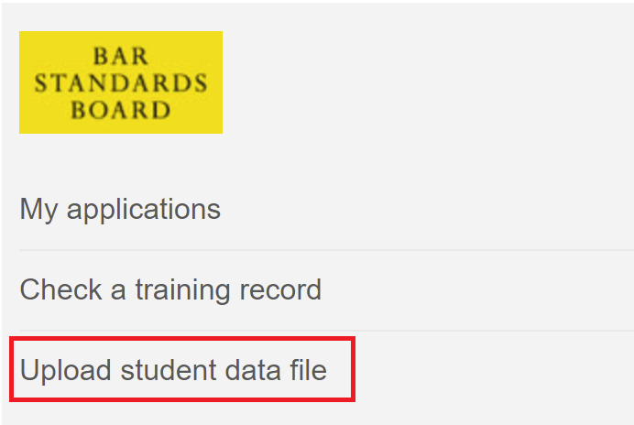
Follow the onscreen guidance. Enter “Results” in the Subject field and use the Description field to indicate whether the uploaded data contains module results, overall results, or both:
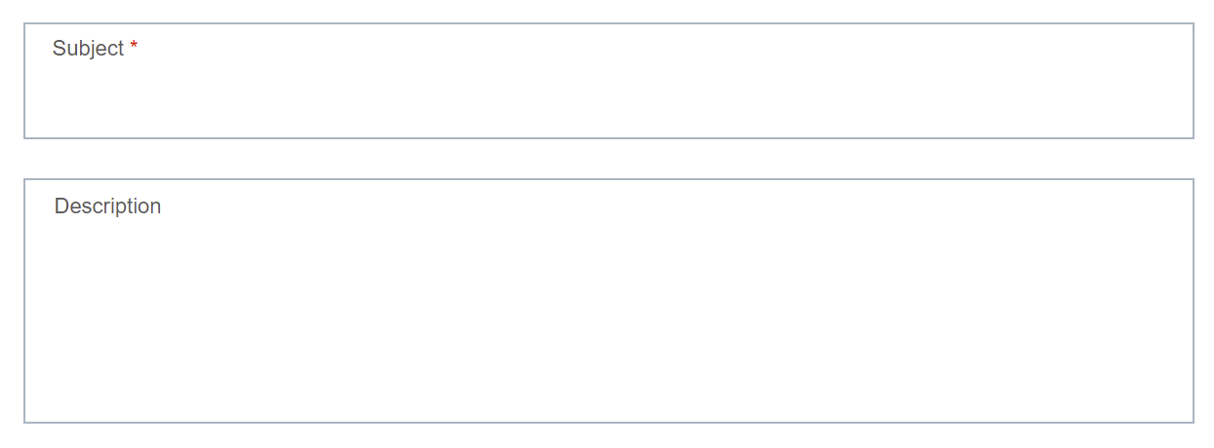
If you need to amend any of the results data you have previously supplied, use the same results template and only supply the details of students that require correction. Please clearly indicate that this is an amendments file when you upload the data in MyBar, by entering “Update to results data” in the “Description” box.
Authorisations Team
The Authorisations Team (we) will receive the data uploaded into MyBar and verify that it meets the requirements for the student training records. Once verified we will import the data into our systems. Both module results and overall results will be uploaded to the existing training record for each student.
We will contact the AETO if the data does meet the requirements and ask for it to be resupplied.
Student
The student (you) will have received a “Welcome to MyBar” email when your training record was first created. This will contain instructions for setting up your personal login for the MyBar portal. Within MyBar you will be able to view your training record and access additional services throughout your career at the Bar.
The academic and vocational data within your training record comes from your AETO. If you believe any of the data is incorrect, please contact your AETO Your AETO can supply updated information to us to ensure your training record is accurate.

FAQs
- [AETO] Do we need to complete a separate template for each module? No, you can enter and upload results for all ten modules on a single template.
- [AETO] Do we need to supply the results for the two centralised exams (Criminal Litigation and Civil Litigation)? Yes, once the marking of the centralised exams is complete, please return the results to us using the supplied template.
- [AETO] We have students enrolled on the earlier BPTC course, should we provide their results using the same template? No, the template is only for students enrolled on the vocational component of Bar training, starting September 2020.
- [AETO] One of our students did not attend an exam. Should we provide a module result for that student? No, please only provide module data for students that attempted the exam.
- [AETO] We do not have a final score for the Legal Research or Professional Ethics modules. What should we do? The “Final Score (1-100)” column for those modules can be left empty. All other module results must be accompanied with a score.
- [AETO] There was a problem with the results data we sent, and we need to provide updated information. How do we do this? Use the same results template and supply the new details for only those students that require correction. When you upload the data to MyBar, please enter “Update to results data” in the “Description” box.
- [Student] The other students on my course received a “Welcome to MyBar” email but I did not. What should I do? Check with your AETO which email address they supplied to us with your enrolment data. Your AETO can request an amendment if this is not correct, and we can resend your Welcome email. If your email address was supplied correctly, contact vbtproviders@BarStandardsBoard.org.uk for assistance.
- [Student] The information on my training record is incorrect. What should I do? Contact your AETO so that they can supply updated information to us.

