Enrolment data
The data for all students enrolling with an AETO on the vocational component of Bar training must be provided to the BSB. This data forms part of the student’s training record with the BSB. Students can view their training record on the secure MyBar portal.
AETOs
The AETO (you) are responsible for providing the BSB with an accurate record of the students enrolled on the vocational component of Bar training. You will need the latest Excel template for enrolment data and a login for the MyBar portal. If you do not have either the template or access to the MyBar portal, contact vbtproviders@BarStandardsBoard.org.uk for guidance.
You must complete the template with the details of all enrolling students, being careful to fully complete all columns marked in red. Additional guidance is provided on the “Guidance” tab of the template. Please note that the academic fields highlighted in blue must be fully completed. Where a student has entered training with a law degree, you should complete the degree columns. Where a student has entered training with a GDL, you should complete both the degree columns – with the details of the student’s first degree – and the GDL columns.
Once you have completed the template, log into the MyBar portal and select “Upload student data file” from the left panel:
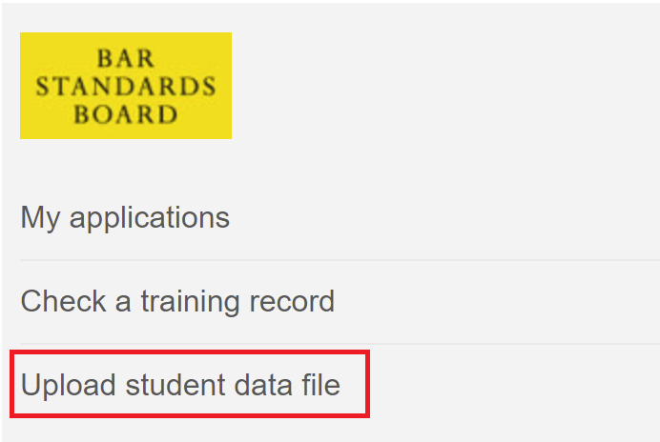
Follow the onscreen guidance. Enter “Enrolment” in the Subject field and use the Description field to indicate the enrolment date:
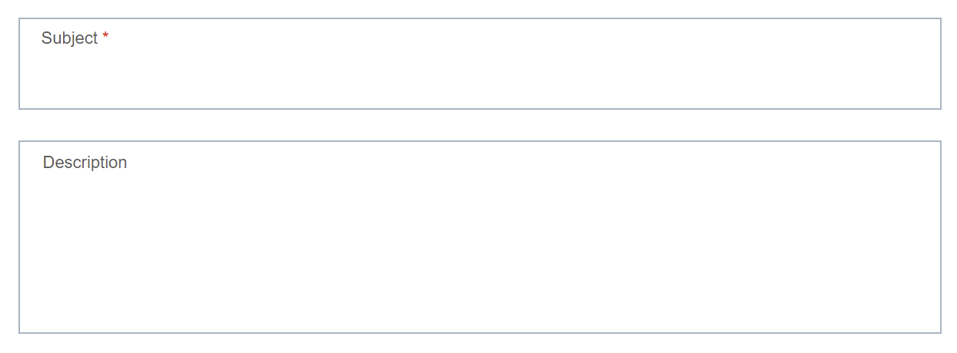
If you need to amend any of the data you have previously supplied, use the same enrolment template and only supply the details of students that require correction. Please clearly indicate that this is an amendments file when you upload the data in MyBar, by entering “Update to enrolment data” in the “Description” box.

Authorisations Team
The Authorisations Team (we) will receive the data uploaded into MyBar and verify that it meets the requirements for the student training records. Once verified we will import the data into our systems. Where a training record already exists for a student, this will be updated with the new enrolment data. We will create a new training record for all other students.
We will contact the AETO if the data does meet the requirements and ask for it to be resupplied.
Student
The student (you) will receive a “Welcome to MyBar” email when your training record is first created. This will contain instructions for setting up your personal login for the MyBar portal. Within MyBar you will be able to view your training record and access additional services throughout your career at the Bar.
The academic and vocational data within your training record comes from your AETO. If you believe any of the data is incorrect, please contact your AETO in the first instance. Your AETO can supply updated information to us to ensure your training record is accurate.

FAQs
- [AETO] We have enrolled a student with a GDL but do not know the details of their first degree. Can we leave those columns blank? The first degree columns must be filled in for all students. Contact the student for details of their academic qualifications prior to GDL.
- [AETO] What should we put in the “Pathway” column? If you are providing vocational training in one part, select “3 part”. If you are providing vocational training in two parts, select “4 part”. If you are providing integrated academic and vocational training, select “Integrated”.
- [AETO] There was a problem with the enrolment data we sent, and we need to provide updated information. How do we do this? Use the same enrolment template and supply the new details for only those students that require correction. When you upload the data to MyBar, please enter “Update to enrolment data” in the “Description” box.
- [Student] The other students on my course received a “Welcome to MyBar” email but I did not. What should I do? Check with your AETO which email address they supplied to us with your enrolment data. Your AETO can request an amendment if this is not correct, and we can resend your Welcome email. If your email address was supplied correctly, contact vbtproviders@BarStandardsBoard.org.uk for assistance.
- [Student] The information on my training record is incorrect. What should I do? Contact your AETO so that they can supply updated information to us.

