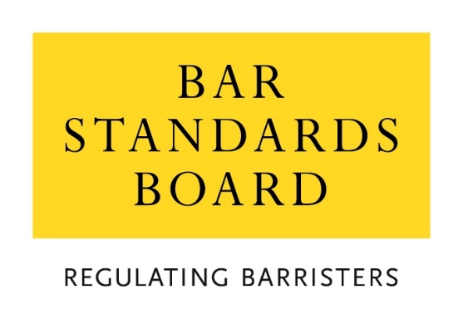

Schedule 2 of the Memorandum of Understanding:
Framework for the provision of Qualifying Sessions

April 2023

Introduction
- This document provides a framework for delivering Qualifying Sessions in line with the terms of the Memorandum of Understanding and accompanying schedules (MOU) between the Council of the Inns of Court (COIC), each of the Inns of Court and the Bar Standards Board (BSB). The aim of this framework is to ensure co-ordination and unification of procedures between the Inns while acknowledging differences in the character and mode of delivery of Qualifying Sessions by individual Inns. The Inns will develop common rules to give effect to this framework and to ensure consistent consideration of applications for waivers. The Parties will review this framework in accordance with provisions of the MOU.
Context for a new framework for Qualifying Sessions
- This framework has been developed to give effect to rQ6.3 in the BSB’s Qualification Rules (Part 4 of the BSB Handbook) which states that “the BSB shall set out in writing the minimum requirements for the delivery of Qualifying Sessions by an Inn.” It has also been developed with regard to the Professional Statement for Barristers, and the four principles of Bar Training: accessibility, affordability, flexibility and high standards.
Why we have Qualifying Sessions
- Qualifying Sessions form a vital part of a student’s journey in training to become a barrister. All students who undertake vocational training for the Bar are required to be members of an Inn. Qualifying Sessions, which take place alongside a student’s vocational training, provide opportunities for professional and ethical development which complements and builds on a student’s academic and vocational education and forms a bridge to the final component of Bar training, pupillage. Qualifying Sessions also provide opportunities for a student to enhance their understanding of the role of barristers in the wider justice system and the rule of law.
- Mixing with practitioners, discussing the practical and ethical elements of being in practice – whether in the self-employed or employed Bar – and practising professional skills in front of practitioners provides a level of reality, and an extra stimulation to learning which complements students’ vocational training. Students need time to reflect on and assimilate what they have learned and experienced. Through the provision of both practical and knowledge-based sessions, delivered by specially selected and trained members of the profession and experts, the Inns help equip students to undertake the next stage of training and to be fit and proper to serve the public as barristers. The links made with the profession through the Inns provide students with a foundation for pupillage and work-based learning but also for a career at the Bar thereafter.
What are Qualifying Sessions?
- There is no set format for a Qualifying Session, but all Qualifying Sessions will have educational content and will provide the opportunity for students to engage with the Inn’s community of practitioners and/or relevant experts. Qualifying Sessions will help students acquire one or more of the knowledge areas, skills or attributes set out in the BSB’s Professional Statement but may also cover more general topics related to the wider workings of the Bar, the administration of justice and the public interest it serves. Additionally, Qualifying Sessions may be used to help students prepare for practice and develop a career whilst addressing wider wellbeing issues in the context of the practising Bar, taking into account issues of contemporary importance.
Qualifying Session Programme
- Each student must attend a minimum of ten Qualifying Sessions, organised by the Inns of Court, in order to provide sufficient opportunity for them to meet with and learn from a variety of practitioners, judges and experts and thereby facilitate integration into the ‘community of practice’.
- Programmes of Qualifying Sessions are designed to be accessible and flexible. Working towards these principles, the Inns shall develop programmes which take into account the need for greater provision outside of London. The Inns may deliver Qualifying Sessions jointly. Students must attend a minimum of one session under each of the themes outlined below and at least two sessions must be interactive and require preparation in advance.
- The five themes, which cover all aspects of the skills and knowledge students need to learn as part of their training for the Bar, are:
- Ethics, Standards and Values;
- Advocacy Skills;
- Legal Knowledge, Justice and the Rule of Law;
- Equality, Diversity and Inclusion; and
- Preparation for Pupillage, Career Development and Wellbeing
- Each Inn will develop and publish a programme of Qualifying Sessions prior to each term with learning aims for each Qualifying Session set out in advance.
- Students will be made aware of each Inn’s programme of Qualifying Sessions, including clear information about what the themes, activities and learning aims will be, and the cost of attending each Session.
Attendance at Qualifying Sessions
- Students, including transferring lawyers and specially qualified applicants, must complete all mandatory Qualifying Sessions prior to being Called. The Inns will each maintain records of the Qualifying Sessions completed by each student. The Inns will make available to the BSB student records at the BSB’s request.
- The Inns will develop their programme of Qualifying Sessions outside of London (not including the South East Circuit) to promote accessibility for all students. Such Qualifying Sessions will comply with this schedule and the rules accompanying this document.
- Attendance at an Inn’s education and training event may count for more than one Qualifying Session. It is for each Inn to determine the number of Qualifying Sessions awarded for attendance at an event on the basis of content and learning aims and in accordance with common rules to be developed.
- Attendance at a student’s Call ceremony and the accompanying event will not count as a Qualifying Session. Attendance at a dinner alone will not count as a Qualifying Session.
- Attendance at a Qualifying Session will not be counted unless the student has paid the prescribed fee (where applicable) and has participated in the whole of the event as required.
- Subject to the paragraph 17 below, a student must attend ten Qualifying Sessions during a period of no more than five years ending on the date on which that person is Called to the Bar.
- An Inn may, on an application showing such exceptional grounds as satisfy criteria to be agreed by all four Inns, waive or modify the requirements to attend Qualifying Sessions.
Quality Assurance
- In order to ensure high standards of delivery and consistency across the Inns, a variety of quality assurance measures will be put in place utilising feedback from students and internal observers. A programme of external observation will also be developed.
- Feedback collected from students should make use of a core set of questions that will be common across the Inns, though each Inn may add other questions if they wish.
- Feedback will also be obtained from internal observers, who will attend a cross-section of sessions delivered by each Inn across a broad range of different themes and types of Qualifying Sessions. Observers will complete a form which will include a core set of questions common to all Inns, though as with student feedback each Inn may also add other questions if they wish.
- COIC and the Inns will develop a biennial programme of external observation and review in order to assure quality, from independent observers. Common assessment forms will be used by the observers for the visits across the Inns.
- The quality assurance programme will accord with Schedule 4 of the MOU.

